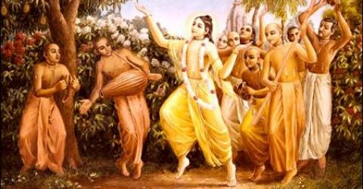

September 2010 Special Edition
www.soldiersofgodhead.yolasite.com

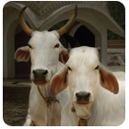

This month’s edition is a special edition dedicated to cow protection.

Contents
Sr. no Topic Page no.
- The significance of cow. 5

- Cruelty of the modern world. 10

- What is cow protection? 16

- Efforts to protect cows. 17

- How can we make a difference? 27

- Fact files about cows. 29

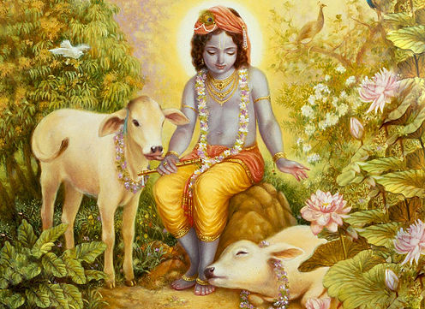
Cow is the dearest of all creatures to Lord Krishna.
- The Significance of Cow
According to vedic injunctions, we have seven mothers- Adi Mata (the original mother), Guru patni (wife of the spiritual master), Rajmata (Queen/ wife of head of state), Dhatri (nurse), Dhenu (Cow) and Dharati (earth). Thus, one not only has his original mother but also six other mothers and man is nurtured by all his seven mothers. The original mother gives birth and fulfills the basic necessities of the child. The wife of the spiritual master also takes motherly care of the disciples of her husband and the queen looks after the welfare of her subjects just like a mother seeks the welfare of her child. The nurse takes care of her patients as a mother takes care of her own child. She selflessly serves her patients just like a mother serving her children. Cow nurtures us with her milk, therefore she is mother. Without any selfish motive or expectations of any returns she nourishes us with her wholesome and nutritious milk. In reality she blesses us in many ways in the form of her milk. We get butter, cheese, butter milk, ghee, curd and many more milk products from her milk. Even her dung is an excellent natural fertilizer for the fields and also an excellent fuel. The earth nourishes us with grains, fruits, shelter, fresh water etc. Thus, anyone who selflessly nourishes us in any way absolutely is mother.
In the Hindu religion, apart from all other mothers, the cow is given the more prominent position. This is so because cow is most dear to Lord Sri Krishna, the Supreme Personality of Godhead. There is a story in this connection in the Srimad Bhagavatam. Once Lord Krishna’s father Nanda Maharaj and his fellow villagers in Gokul were planning to organize a sacrifice (Yagya) to satisfy Indra (the rain god) to ensure plenty rainfall for a good harvest. Lord Krishna who was only a boy then, protested against this idea of demigod worship. He explained to His father and other villagers that the demigods like Indra, Surya (sun god), Chandra (moon god), the nine planets, Varun, Vayu etc are not supreme but only empowered agents of God. It is their duty to ensure that habitable conditions prevail on earth for the survival and progress of all living entities. They need not be worshiped for carrying on their duty. Instead, Lord Krishna advised, that the villages should worship the cows who are the source of their livelihood. He asked all the villagers to go to Govardhan Hill and worship the cows there. When the villagers went to the Govardhan Hill, Indra got angry because the villagers were not going to worship him. He unleashed his wrath on the village. There was tremendous rain, floods and thunderstorms. All the houses, fields and forests were destroyed. To protect His devotees, Lord Krishna lifted the Govardhan Hill on His little finger and stood with it for seven nights and days and the villagers and animals took shelter under the hill till the wrath of Indra subsided. Having understood his mistake, Indra sought the forgiveness of Lord Krishna. The ocean of mercy, Lord Krishna forgave Indra. Hence, one of the names of Lord Krishna is also Govardhangiridhardhari or the one who lifted the Govardhan Hill.
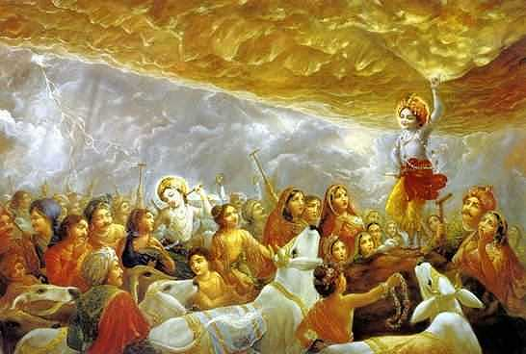

As per Lord Krishna’s advise, all the inhabitants of Gokul worshiped the cows and there was never shortage of rain or grains in their village and prosperity was widespread in the village of Gokul. Hence, the cow is the most sacred of all creatures owing to the very fact that she is most dear to Lord Krishna. In fact, unlike the cows in this material world the cows in Lord Krishna’s planet Goloka Vrindavan are called the Surabhi cows. They provide unlimited suppy of milk to the inhabitants of Goloka and are personally loved and looked after by Lord Krishna Himself. Another point worth noting here is that Lord Krishna’s planet is called Goloka Vrindavan which means the planet of cows (Go) and tulsi (vrinda). Since both cows and Tulsi are profoundly dear to the Lord, they are most sacred and worshipable.
Hare Krishna!

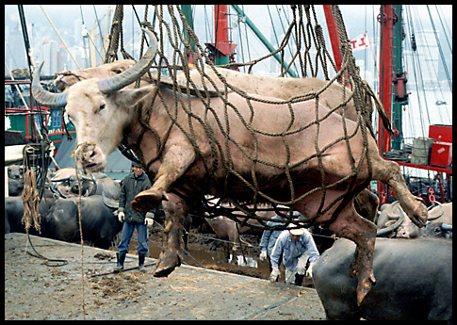
Cows being taken for slaughter

- Cruelty of the modern world.

T
he modern world speaks about material progress and development of new means for sense gratification. But in pursuit of this material development and so called progress, we have systematically uprooted the most important aspect of life, the spiritual aspect. Today there is disturbance in society. We have problems like terrorism and global warming threatening the entire human society and we want an end to these problems so that we can have unrestricted sense gratification and unlimited sources for the same. Most of the time, people want “God’s kingdom” without God in it, but they cannot have it.
This world operates on the principles of Karma (action and reaction of the actions performed). There can be no peace in the human society as long as we are slaughtering our brothers, the animals. For the fulfillment of our selfish motives we take to animal killing and expect peace and prosperity for ourselves. But there can be neither peace nor prosperity for a society which does not adhere to the rules and regulations of the shastras. Many people justify animal killing on the grounds that the life of man is more important than that of the animals. But only an ignorant person can speak in this manner. As per the Padma Puran there are 8.4 million species of life forms in the material world. Before reaching the human form of life, one must go through these different life forms and at the end one reaches this valuable human form of life where one has the capacity to inquire about himself and his relation to Lord Krishna. But, supposing one is in the body of a lower animal like goat or chicken and he is killed for his flesh then owing to an untimely death, he must retake birth in that particular species for progressing into higher forms of life. So, when we kill any living entity, be he an animal or human, we are checking the progress of that entity and this is a gross sin. It is mentioned in the Srimad Bhagavatam, that when someone for his own selfish motive harms any insignificant living entities like animals, he is sent to a hell known as Rourava where there are creatures known as Rurus who torment and punish the sinful for the harm he had inflicted on the living creatures during his life time.
Our principle of avoiding meat eating is very simple. We are enjoined by Krishna in the Bhagavad-gita 3.13 that we can only take Krishna prasadam as our food, that if we eat food that has not been offered to Krishna we are eating only sin. And in Bhagavad-gita 9.26 Krishna lists which kinds of foods are acceptable for being offered to Him. He only lists vegetarian foods. He does not ask for flesh. Therefore since flesh cannot be offered and since unoffered food is sinful, meat eating is sinful.
The sinfulness of meat eating is also confirmed in the Vedic literatures as follows:
na māṁsa-bhakṣaṇe doṣo
na madye na ca maithune
pravṛttir eṣā bhūtānāṁ
nivṛttis tu mahā-phalā
"It may be considered that meat-eating, intoxication and sex indulgence are natural propensities of the conditioned souls, and therefore such persons should not be condemned for these activities. But unless one gives up such sinful activities, there is no possibility of achieving the actual perfection of life."
--Manu-saṁhitā 5.56
ye tv anevaṁ-vido 'santaḥ
stabdhāḥ sad-abhimāninaḥ
paśūn druhyanti viśrabdhāḥ
pretya khādanti te ca tān
"Those sinful persons who are ignorant of actual religious principles, yet consider themselves to be completely pious, without compunction commit violence against innocent animals who are fully trusting in them. In their next lives, such sinful persons will be eaten by the same creatures they have killed in this world."--SB 11.5.14
There are also many arguments against meat eating from the environmental perspective. For some of these please refer to the following web page for more information: www.ultimateselfrealization.com/Meat_and_the_Environment
- Sankarshan Das Adhikari

Apart from animal killing, Cow slaughter is the worst of all sins in the three worlds. Harming a devotee of the Lord, harming a cow, disrespecting the deity of the Lord or impurifying the place of worship, are some of the grossest sins. In the modern world which is obsessed with sense gratification, these sins are committed on a daily basis somewhere or other. So when we live in such a sinful world, how can there be any peace or prosperity? In many parts of the world and also in India, cows are daily slaughtered in slaughter houses. We drink cow’s milk as long as she can provide it to us and later when she is old and unable to provide us with milk, we sell her to the slaughter houses so that we need not spend any money on taking care of her in her old age. This is the way we repay our mother and expect peace and prosperity for ourselves.
In most parts of the world, cows are slaughtered for their meat. But the human society should understand that the foods for man are grains, pulses, vegetables, fruits, milk, milk products etc. When one can survive and lead a healthy life on a pure vegetarian diet, why should the animals and especially cows be slaughtered for their meat? Most people have the misconception that vegetarian foods are not rich in proteins or fats. Pulses and curd are rich sources of proteins and fats can obtained from milk, potatoes and other milk products. Cows need not be slaughtered for proteins or fats since they are available in plenty in pure vegetarian food stuffs.
However, as long as this cruel maintenance of slaughter houses continues, there is a guarantee of continued disorder and disturbance in the human society. As per the laws of karma, violence is repaid in violence. Hence, as long as we continue to inflict harm on sacred creatures like cows and other creatures in the lower forms of life, there cannot be any peace, prosperity or spiritual progress in the human society. The purpose of this human form of life is to love and understand God. But as long as one will remain sinful how can he understand God and what is the question of loving Him?

Hare Krishna!

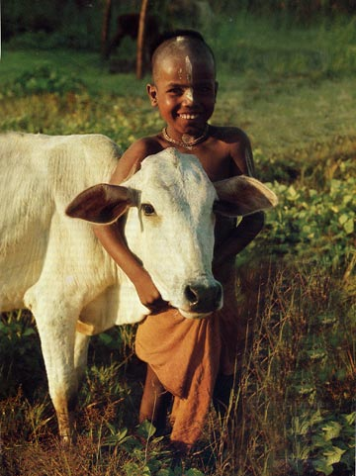
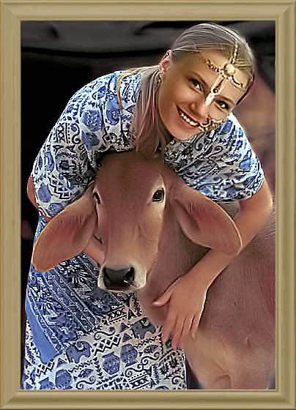

- What is Cow Protection?

C
ow protection is basically any effort taken towards preventing cow slaughter and any form of abuse to cows, rescuing cows from the clutches of slaughterers and rehabilitating and rearing the cows with pure love and devotion. In spite of fall in religious principles in the modern age, cow protection has been promoted by various religious groups/organizations and effective measures are being taken to put an end to this gross sin of cow slaughter.
Since cows are sacred creatures in the Hindu religion, cow slaughter is banned in countries like India where nearly 80% of the population is Hindu. Not only in India, but also in various countries around the globe, cow protection is gaining importance thanks to the efforts of the International Society for Krishna Consciousness (ISKCON) and their cow protection program. The Hare Krishna Movement in the western countries is educating westerners about the significance of cows through their literatures, book distribution efforts, development of farm communities and discourses.

- Efforts to Protect Cows
P
rotection of Cows is the single-most important principle towards saving the whole world from both moral and spiritual degradation. Simply by protection of Cows all the wonderful benefits of religiosity and piety will be automatically achieved without any separate endeavor. This is because Cows are as beloved to the Supreme Personality of Godhead, Lord Krishna, as even saintly brahmanas.
In scriptures it is said, namo brahmanya-devaya go-brahmana-hitaya ca jagad-dhitaya krsnaya govindaya namo namah, "My Lord, You are the well-wisher of the Cows and the brahmanas, and You are the well-wisher of the entire human society and world." (Visnu Purana 1.19.65) Lord Krsna, the Supreme Personality of Godhead, is the prime protector of brahminical culture and the Cow. Without knowing and respecting these pleasing personalities, one cannot realize the science of God, and without this knowledge, any welfare activities or humanitarian propaganda cannot be successful. SB 4.21.38 purport
For the Cowherd men and the Cows, Krishna is the supreme friend. His pastimes in Gokula, His dhama, are always favorable to the brahmanas and the Cows. His first business is to give all comfort to the Cows and the brahmanas. In fact, comfort for the brahmanas is secondary, and comfort for the Cows is His first concern. Because of His presence, all people would overcome all difficulties and always be situated in transcendental bliss. SB10.8.16
Krishna says in Srimad Bhagavatam, “I can be worshiped within the Cows by offerings of grass and other suitable grains and paraphernalia for the pleasure and health of the Cows, and one may worship Me within the Vaishnavas by offering loving friendship to them and honoring them in all respects.” SB11.11.43
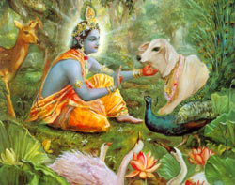
Human society needs only sufficient grain and sufficient Cows to solve its economic problems. All other things but these two are artificial necessities created by man to kill his valuable life at the human level and waste his time in things which are not needed. Lord Krishna, as the teacher of human society, personally showed by His acts that the mercantile community, or the vaisyas or business or trading community, should herd Cows and Bulls and thus give protection to these valuable animals. According to smrti regulation, the Cow is the mother and the Bull the father of the human being. The Cow is the Mother because just as one sucks the breast of one's Mother, human society takes Cow's milk. Similarly, the Bull is the Father of human society because the Father earns for the children just as the Bull tills the ground to produce food grains. Human society will kill its spirit of life by killing the Father and the Mother. SB 3.2.29 purport
The Cow is the most important animal for developing the human body to perfection. The body can be maintained by any kind of foodstuff, but Cow's milk is particularly essential for developing the finer tissues of the human brain so that one can understand the intricacies of transcendental knowledge. A civilized man is expected to live on foodstuffs comprising fruits, vegetables, grains, sugar and milk. The Bull helps in the agricultural process of producing grain, etc., and thus in one sense the Bull is the father of humankind, whereas the Cow is the Mother, for she supplies milk to human society. A civilized man is therefore expected to give all protection to the Bulls and Cows. SB 3.5.7 purport
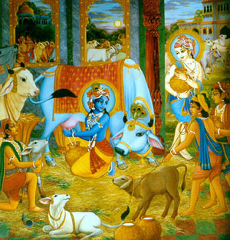
Lord Krishna’s Example
To teach by example, the Supreme Lord Sri Krishna and Lord Balaram show us when They descend into this world, how important is to protect, love and serve Cows and Bulls. Krishna is known as Gopala (protector of the Cows) or Govinda (one who gives pleasure to the Cows). Lord Balaram represents plowing the land for agriculture and therefore always carries a plow in His hand, whereas Krishna tends Cows and therefore carries a flute in His hand. Thus the two brothers represent krisi-raksha (protecting Bulls by engaging them in farming) and go-raksha (protecting the Cows). 10.5.20 Purport
“Offering respect to the Cows will help the devotee to diminish the reactions to his past sinful activities” (Skanda Purana)
Vrindavan’s Cows are constant remainders of Krishna’s ecstatic Cow herding lilas (pastimes). By serving the Cows one receives tremendous spiritual benefit. Feeding grains to the Cows, offering puja, or simply a scratch under the neck will please these peaceful personalities and attracts the attention of Supreme Personality of Godhead Sri Govinda. The Gautamiya Tantra says, “One should gently scratch the body of a Cow, offer her a mouthful of green grass and reverentially circumambulate her. If Cows are maintained nicely and comfortably, Lord Gopal will be pleased.”
Thereafter, mother Yashoda and Rohini, along with the other elderly gopis, waved about the switch of a Cow to give full protection to the child Sri Krishna.
PURPORT: When Krishna was saved from such a great danger, mother Yashoda and Rohini were principally concerned, and the other elderly gopis, who were almost equally concerned, followed the activities of mother Yashoda and Rohini. Here we find that in household affairs, ladies could take charge of protecting a child simply by taking help from the Cow. As described here, they knew how to wave about the switch of a Cow so as to protect the child from all types of danger. There are so many facilities afforded by Cow protection, but people have forgotten these arts. The importance of protecting Cows is therefore stressed by Krishna in Bhagavad-gita (krisi-go-raksha-vanijyam vaisya-karma svabhavajam [Bg. 18.44]). Even now in the Indian villages surrounding Vrindavana, the villagers live happily simply by giving protection to the Cow. They keep Cow dung very carefully and dry it to use as fuel. They keep a sufficient stock of grains, and because of giving protection to the Cows, they have sufficient milk and milk products to solve all economic problems. Simply by giving protection to the Cow, the villagers live so peacefully. Even the urine and stool of Cows have medicinal value. SB 10.6.19
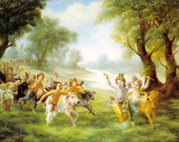
The child was thoroughly washed with Cow urine and then smeared with the dust raised by the movements of the Cows. Then different names of the Lord were applied with Cow dung on twelve different parts of His body, beginning with the forehead, as done in applying tilaka. In this way, the child was given protection. SB 10.6.20
Even in the houses of the cultivators, who were not very advanced in the modern ways of civilization, the ladies used to know how to chant mantras to give protection to children with the help of Cow dung and Cow urine. This was a simple and practical way to give the greatest protection from the greatest dangers. People should know how to do this, for this is a part of Vedic civilization. SB 10.6.22-23 purport
Srila Rupa Goswami cites one example to show the depth of Sri Radhika’s mercy towards the Cows, “Seeing a calf with its mouth pierced by a sharp grass, Sri Radhika felt very unhappy. With tears in Her eyes Radhika immediately dressed the calf’s wound with red kunkuma (a mixture of saffron and turmeric) (Ujjvala Nilamani)

The duty of every leader
Once when the great King, Maharaj Parikshit was traveling, he saw a cruel man hurting the legs of a cow and a bull. The King at once caught hold of him to punish him suitably, since in Vedic culture it was considered a great offence to kill or even hurt a cow or bull. As the ideal head of the state, King Parikshit was aware of the importance of protecting cows.
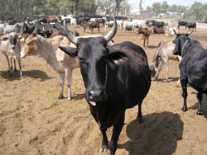
The Tragedy of the Modern Age
The cruel man above is representative of the mentality of the people of the current age, i.e. Kali Yuga, where cow-slaughter has become common, even in India, where the cow was revered as “MOTHER” till some time ago.
The above story of Maharaja Parikshit was being narrated by the great devotee, Suta Goswami, to many sages assembled at a holy place called Naimisaranya over 5000 years ago. This was a little before this age of Kali began. These sages could not believe that in the coming days of Kali Yuga people would kill cows. The idea was so shocking to them. What would these great sages say today if they saw that the very leaders who are supposed to protect cows, like Maharaja Parikshit did, are instead opening organized slaughter houses for killing cows?
The importance of cows and bulls
The people of our times have forgotten that the Cow is the most important animal for human society. The Bull is the emblem of Dharma and cow is the representative of the Earth. When the Bull and Cow are in a joyful mood, it is to be understood that the people of the world will also be in a joyful mood. The reason is that the Bull helps in production of grains in the agricultural field, and the Cow delivers milk, the miracle food which can be further converted into curd, yogurt, butter and ghee. Milking a Cow means drawing the principle of religion in liquid form. Cow’s milk is so pure that it is considered liquid religiosity. So in scriptures Cow is considered to one of our MOTHERS. The Cows give milk and the Bull gives grains through tilling the land, they are considered the MOTHER and the FATHER of human society. Both the Cow and Bull are symbols of the most offenceless living beings because even their dung and urine are of IMMENSE VALUE (medicinal, fuel, etc.) to human society.
Our Responsibility
Human society must, therefore, maintain these two animals carefully. But, unfortunately, both are being slaughtered in large numbers, in India itself it is 60,000 per day and in U.S. on weekends it is 1, 59,500 according to recent statistics. These greatly sinful acts are responsible for so many troubles in present society. To kill cows means to end human civilization. People do not know what harm they are doing in the name of economic development. They do not realize that only by seeing that bulls and cows are happy in all respects, human society can be happy. This is a FACT by the LAWS OF NATURE.
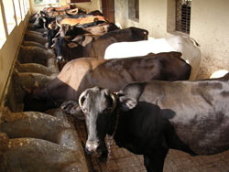
ISKCON’s Role In Cow Protection
A.C. Bhaktivedanta Swami Prabhupada, the Founder Acharya of the International Society for Krishna Consciousness (ISKCON) and one of the greatest spiritual ambassadors of India in recent times, spoke often with great force and feeling on the need to protect cows. Guided by his teachings and inspired by the strength of his personal conviction, ISKCON has played a pioneering role in advocating and practicing cow protection by establishing farm communities, Goshalas, etc., all over the world.
Bhaktivedanta Swami Goshala, ISKCON, Vrindavan
In 1976, Srila Prabhupada began the Bhaktivedanta Swami Goshala at the Krishna Blalaram Mandir in Vrindavan. Ramana Reti, the land of soft pleasing sands, is famous as the place where Krishna and Balarama wandered along the banks of the Yamuna river with Their Cows.
In this Goshala, we are trying to serve the noble cause of cow protection in a humble way. In this Goshala, the Cows, Bulls and Calves are looked after with great care and love. These animals are never sold to slaughter houses or abandoned even when they become old. They are maintained till the end of their lives very happily.
The Goshala has provided pure Cows milk to Their Lordships and the devotees since 1976. Beginning with only 10 milking Cows, the herd has grown more than 300 Cows, Bulls and calves. The Goshala provides loving shelter to all of the animals, and cares for them throughout their lives. However, there is a great struggle to maintain so many animals since only a small number of herd produces milk. Over and above maintenance, there is a pressing need for more land to graze the animals and grow food for them.
Protection of cows and bulls is possible only when cultured and pious minded citizens come forward to actively support the cause by their words, actions and wealth. It is the responsibility of every one of us.
Hare Krishna!

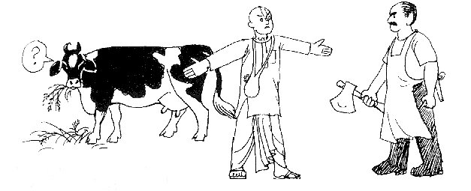
Lets take a pledge to protect our mother!

- How can we make a difference?
Protecting cows is not only the responsibility of religious organizations or other NGO’s but of every individual who drinks the milk of this highly sacred creature. One need not adopt a cow and look after it but one can certainly spread some awareness in regard of cow protection and its significance.
Certain things that an individual can do with little or no resources are:-
- Spreading awareness regarding cow protection
- Never eat meat of cow or bulls
- Never harm cows
- File a complaint with animal rights commission or NGO’s committed towards protection of animals in case cows are being slaughtered in your locality/ neighborhood or at any other location.
- File petitions to prohibit slaughter of cows and other sacred creatures.
- Learn about the laws relating to animal rights and prohibition of cow slaughter in your country and educate people regarding them.
These are certain efforts an individual can take to contribute towards the protection of his mother. It does not take much financial resource to spread awareness regarding the significance of cow and the sins incurred from cow slaughter. Even through casual talks with friends or relatives one can spread this awareness. The first thing one must do in order to protect cows is to stop eating the flesh of cows and bulls (if he or she is eating them). Only then can one become fit to spread awareness in this regard. Before we preach we must practice. Hence by stopping cow slaughter and cow meat eating one becomes fit for preaching. One may also avoid leather articles like belts, shoes, purse etc. Writing blogs, sending emails to friends about the latest developments in cow protection and supporting the ISKCON cow protection program, etc also are some of the effective techniques an individual can adopt in order to protect the holiest creatures in the world.
Hare Krishna!

- Fact Files about Cows
The following are some of the startling facts about cows:-
- When one looks into the eyes of a cow, one can see there the reflection of the eyes of his own mother.
- In case you are suffering from high blood pressure, spend five minutes every day for a week gently moving your hand back and forth on the back of a cow. See the difference in your health within a week!
- While leaving for an important work during the day, if you happen to see a cow on the way, consider your work done. And if the cow is feeding her young one, you can tie a piece of cloth on your eyes and go forward for your work.
- Modern medical science now recognizes the medicinal properties of the bodily wastes of cows. The cow’s urine is proven to be an excellent cure for skin related ailments.
- The cow dung is an excellent fuel & fertilizer. Even a barren piece of land can be made fertile with the help of cow dung. In rural India, cow dung is also used to cool the walls and roofs of houses as it is also an excellent coolant!
- 33 crore demigods reside in a cow! This is another reason why she is considered holy.
- By regular service to cows, one becomes free from the reactions of his past sinful activities and becomes a fit candidate to go back home, back to godhead!
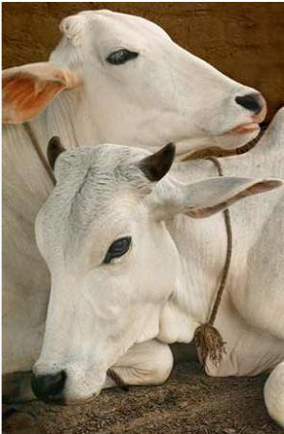

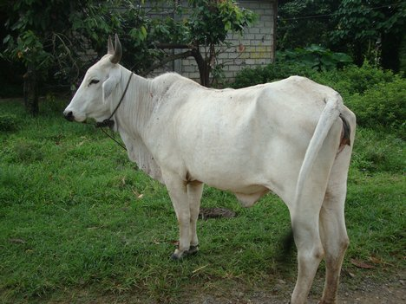

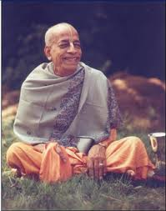

Dedicated to His Divine Grace A.C. Bhaktivedanta Swami Prabhupada, Founder Acharya of the International Society for Krishna Consciousness (ISKCON)

Written, Edited, Published and Distributed by,
Rasabihari Dasa (Vinay D Chakraborty)

Log on to www.soldiersofgodhead.yolasite.com for more information or write into vinay.chakraborty@yahoo.com. Do send in your reviews, suggestions, comments or queries.

Related Sites:-
www.VaishnavaTV.yolasite.com
www.SSRRET.yolasite.com
www.Lalive.us
www.Krishna.com

Hare Krishna!

